### **🔧 What is "Build Periodically"?**

The **"Build Periodically"** option in Jenkins uses **cron syntax** to schedule jobs at specific times—**regardless of code changes**. It's often used for:

* Nightly builds
* Frequent CI runs (e.g., every 15 minutes)
* Regular test deployments

📅 Cron Syntax in Jenkin

Format:

MIN HOUR DOM MONTH DOW

| **Field** | **Description** | **Possible Values** |
| --- | --- | --- |
| MIN | Minute | 0–59 |
| HOUR | Hour | 0–23 |
| DOM | Day of Month | 1–31 |
| MONTH | Month | 1–12 or JAN–DEC |
| DOW | Day of Week | 0–7 (0 and 7 = Sunday) |

You can also use special characters:

* *: every value
* H: hash-based (spreads load)
* /: increments (e.g., H/15)
* ,: separate values (e.g., 1,15)
* -: ranges (e.g., 1-5)
* H/2 * * * *: every 2 minutes (spreads load)

✅ Examples with Real-World Use Cases

| **Cron Pattern** | **Description** | **Use Case Example** |
| --- | --- | --- |
| H/2 * * * * | Every 2 minutes | Quick feedback loop for fast-moving projects |
| 0 * * * * | Every hour | Hourly data sync or job summary builds |
| H 3 * * * | Every day at 3 AM | Nightly regression test suite |
| 15 2 * * 1-5 | 2:15 AM on weekdays | Weekday-only early morning build jobs |
| H 22 * * 5 | Every Friday at 10 PM | Weekly backup or environment refresh |
| 0 0 1 * * | Midnight on the 1st of every month | Monthly reports or billing process |
| */15 9-17 * * 1-5 | Every 15 min between 9 AM–5 PM on weekdays | Frequent CI builds during work hours |

### 

### **🧠 Jenkins Special: Use of H**

The H spreads jobs across time to **avoid load spikes** if multiple jobs use the same schedule.

* Example: If you set H 4 * * *, Jenkins will pick a random but stable minute for each job at hour 4 to distribute load.

### **👨‍💻 Your Configuration:**

From your screenshot:

H/2 * * * *

* **Meaning**: Jenkins will run the job **every 2 minutes**.
* **Real-World Example**: Perfect for a continuously running integration pipeline that watches for issues quickly, such as a **staging environment build or test**.

### **✅ Jenkins Job: Assignment03 – Step-by-Step Detailed Explanation**

**Objective**: Automatically build your Maven project every 2 minutes using Jenkins’ Build Periodically feature (without requiring code changes).

.

### **🔁 STEP 1: Job Setup**

* Job Name: Assignment03
* Type: **Freestyle Project**
* Purpose: Clone the repo, compile, and package it via Maven every 2 minutes.

### 

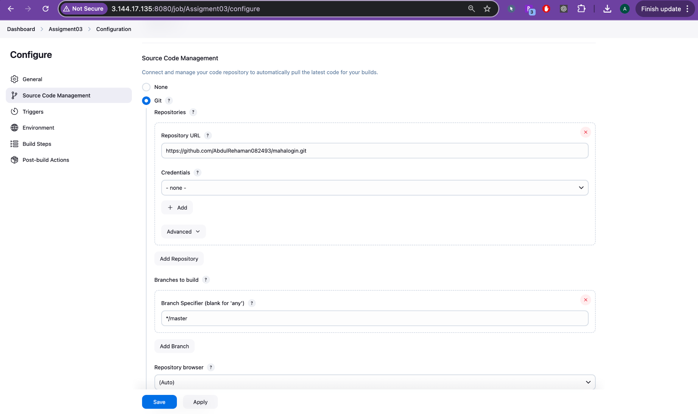

### **🔧 STEP 2: Source Code Management (Git)**

**Location**: Configure > Source Code Management

| **Field** | **Value** |
| --- | --- |
| **Repository URL** | https://github.com/AbdulRehaman082493/mahalogin.git |
| **Credentials** | - none - (public repo) |
| **Branch** | */master (default main branch) |

✔️ This allows Jenkins to pull code from the master branch of your GitHub repository.

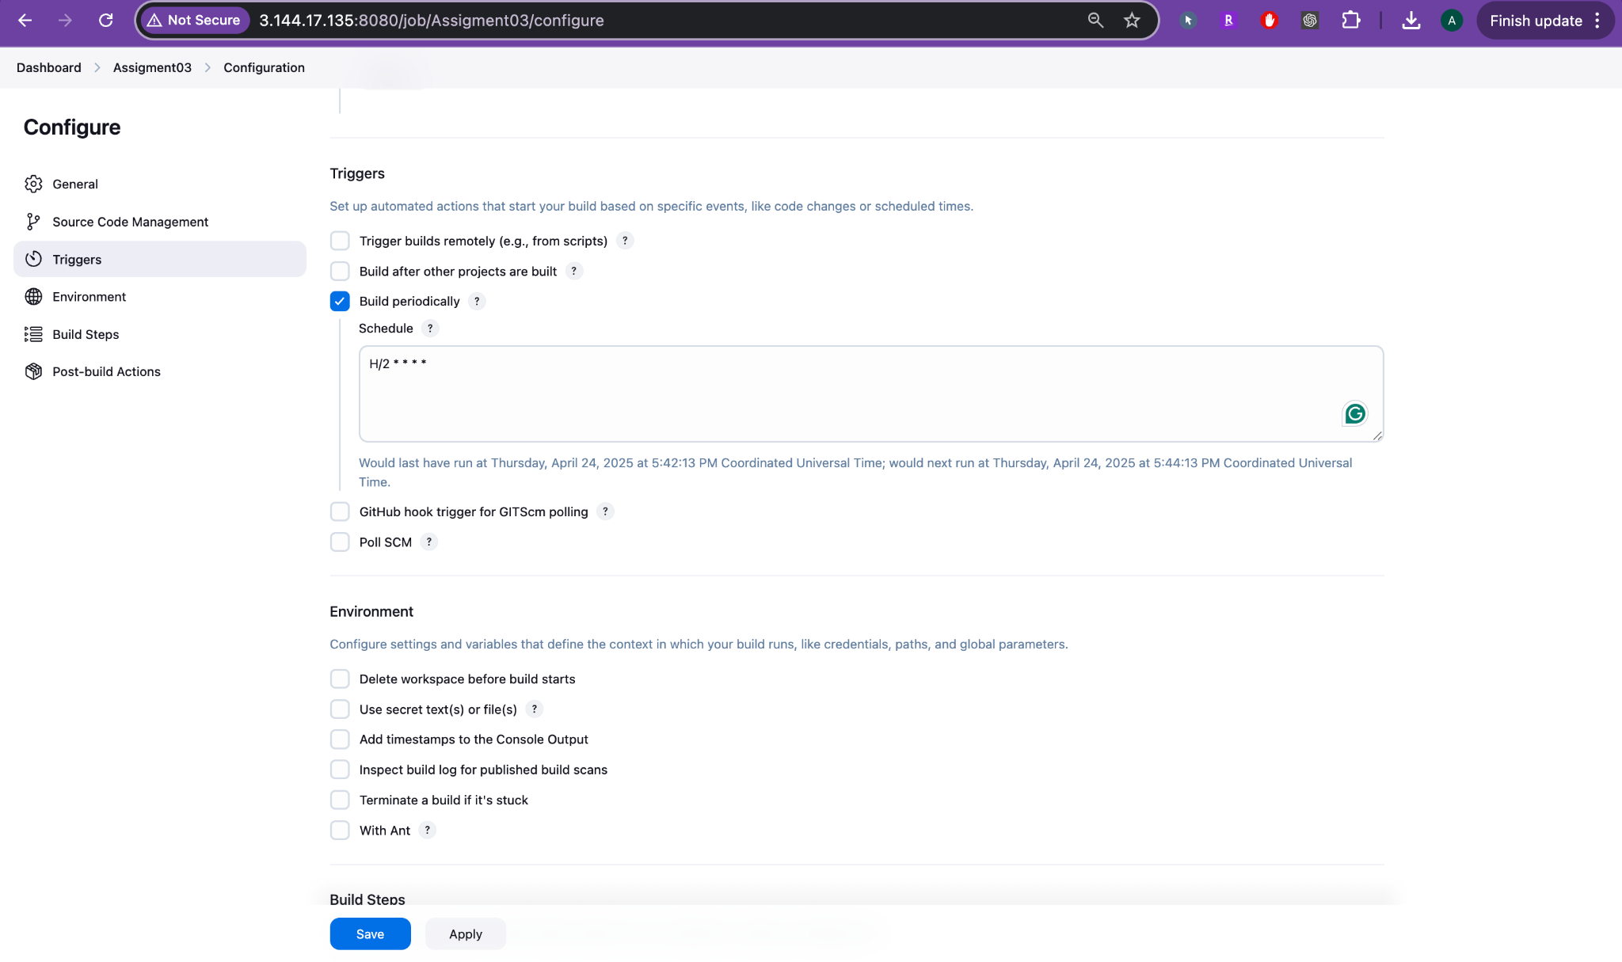

### **⏱️ STEP 3: Build Trigger – Build periodically**

**Location**: Configure > Triggers

You checked ✅ Build periodically and used this schedule:

H/2 * * * *

| **Field** | **Meaning** |
| --- | --- |
| **H/2** | Randomized minute offset; builds every 2 minutes |
| **\*** (next four fields) | Every hour, day, month, and day of the week |

🔁 **Effect**: Jenkins triggers this job **every 2 minutes** continuously — **even if no code changes** have happened.

✅ Useful for:

* Continuous testing
* Monitoring
* Scheduled builds

📌 **Not dependent** on Git commits or polling — it's purely based on time.

### **⚙️ STEP 4: Build Step – Maven**

**Location**: Configure > Build Steps

| **Field** | **Value** |
| --- | --- |
| **Build Step** | Invoke top-level Maven targets |
| **Goals** | clean install |

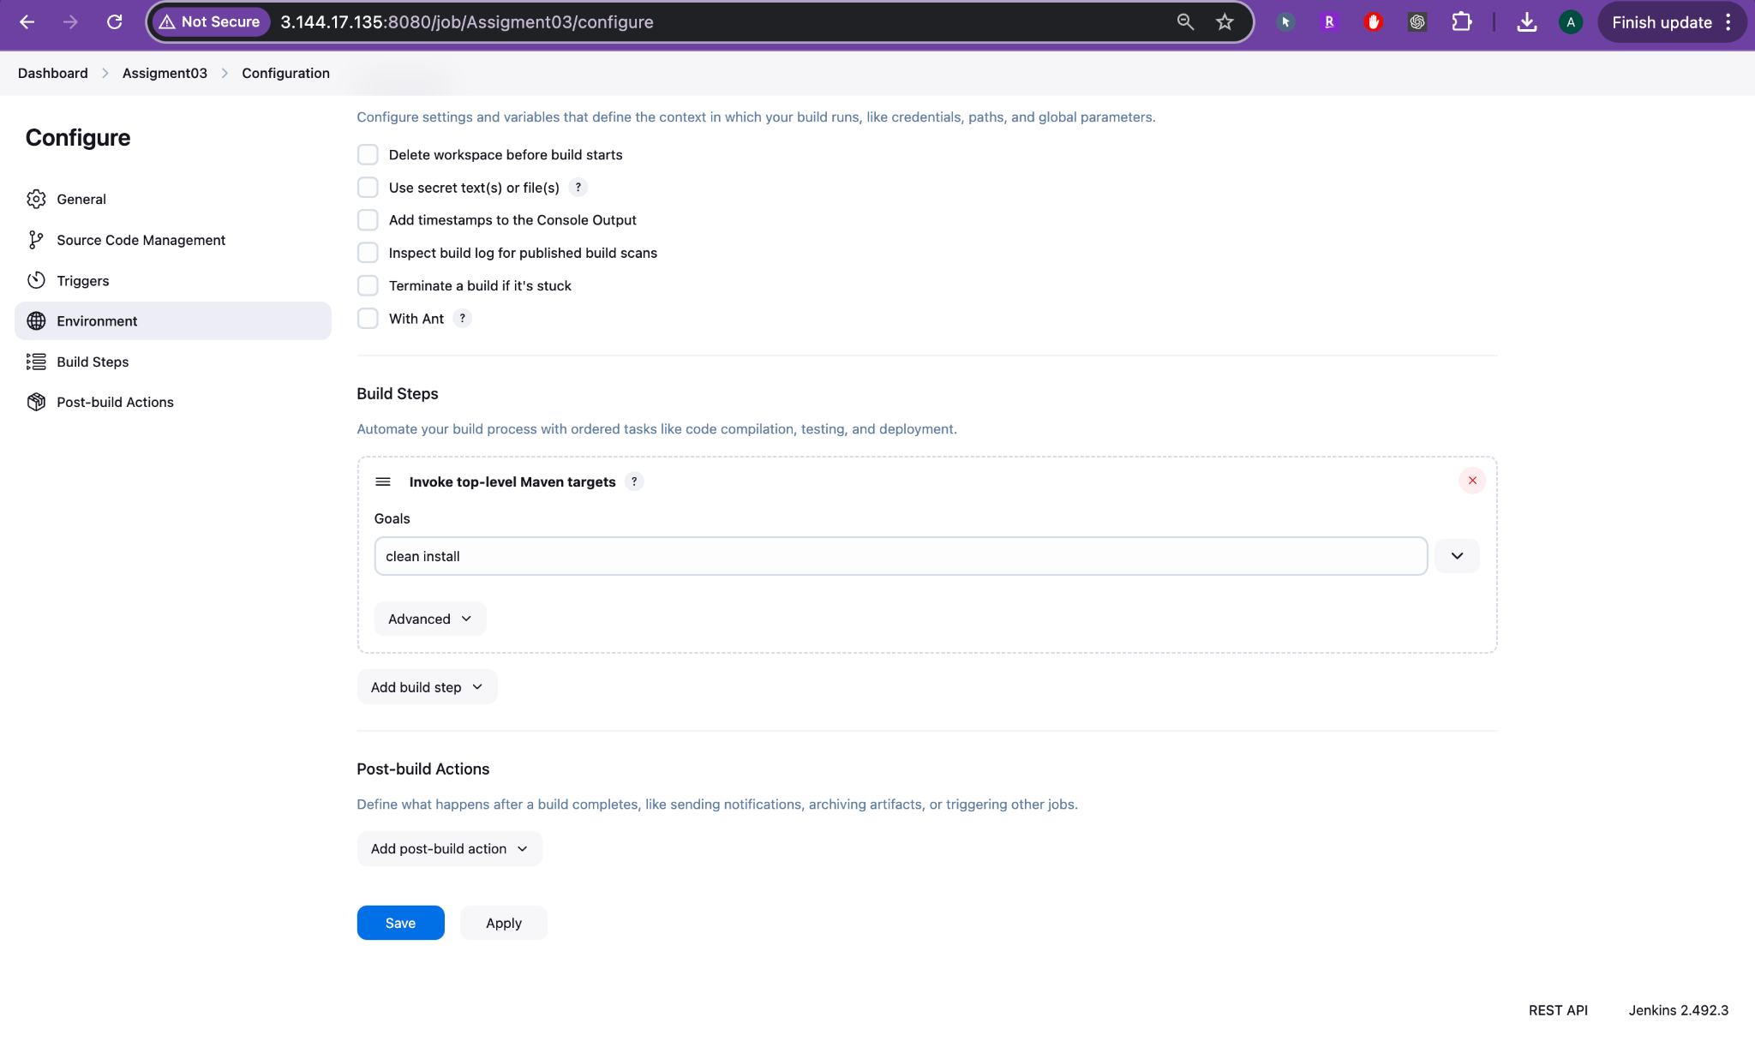

✔️ What it does:

* clean: Deletes target/ directory to ensure a fresh build.
* install: Compiles, runs unit tests, packages .war, and installs it to the local Maven repository.

Resulting artifact:

/var/lib/jenkins/workspace/Assignment03/target/mahaLogin-2.0.war

### **🧪 STEP 5: Environment and Post-Build (Optional)**

None configured in your setup. You may optionally:

* Delete workspace before build
* Add post-build steps like notifications or deployment

### **📋 STEP 6: Jenkins Build Output**

**Location**: Assignment03 > Status

* You see a list of builds triggered every 2 minutes (✅ Build #1 through #7).
* Each build was successful (green check).
* Builds are automatically triggered without manual clicks.

✅ Final Outcome

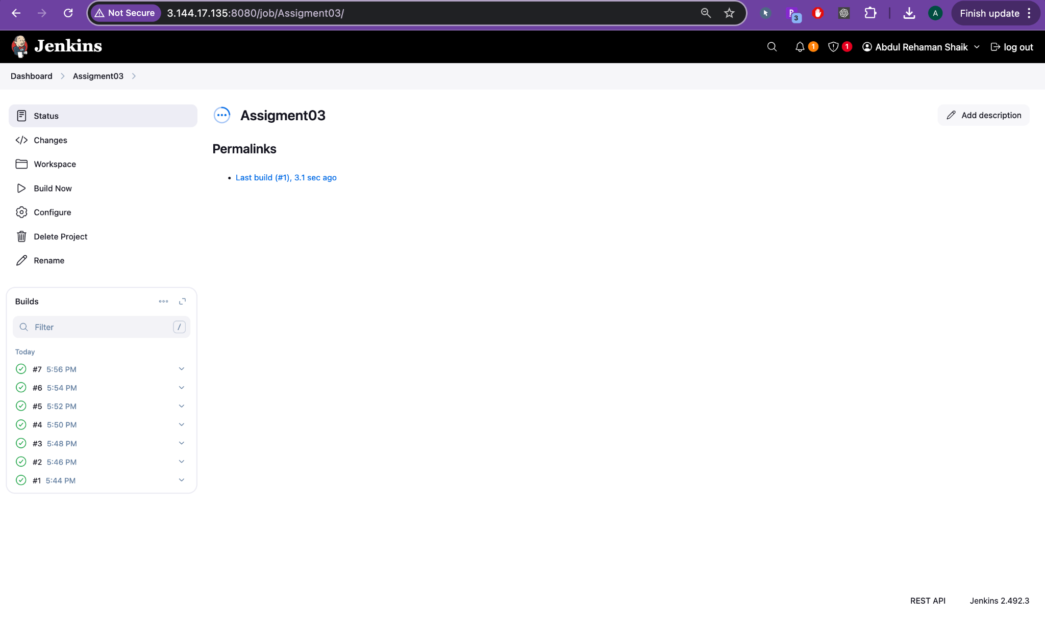

| **Componet** | **Configuration** |
| --- | --- |
| Git Repo | GitHub repo with master branch |
| Trigger | Every 2 minutes (H/2 * * * *) |
| Build Step | Maven: clean install |
| Output | .war file built and installed to local .m2 |
| Status | Multiple successful automated builds |

### **🔄 Optional Enhancements**

Want to:

* Deploy .war file to Tomcat?
* Add webhook for GitHub triggers?
* Archive build artifacts?
* Email build results?

Let me know and I’ll guide you step-by-step!